Analysis of existing AWSI related implementations

AgentWeb Gateway for dynamic and seamless integration of
FIPA Multi Agent System and W3C Web Service System

M. Omair Shafiq, Arshad Ali
NUST Institute of Information Technology
National University of Sciences and Technology (NUST)
Chaklala Scheme III, Rawalpindi, PAKISTAN
{omair.shafiq,arshad.ali}@niit.edu.pk

Hiroki Suguri, H. Farooq Ahmad
Communication Technologies
2-15-28 Omachi, Aoba-ku,
Sendai, 980-0804 JAPAN
{suguri,farooq}@comtec.co.jp

We aimed to develop an information system having capabilities of Web services, Grid computing and Multi Agent Systems. Web Services to support loosely coupled, implementation neutral and heterogeneous resources, Grid computing to support coordinated resource sharing among dynamic virtual organizations and Multi Agent Systems to support autonomous behavior, semantic interoperability among different entities i.e. Software Agents. Web Services and Grid Computing standards have been merged together as Web Services Resources Framework (WSRF). We have focused on integration of Software Agents and Web services. Software Agents in FIPA Multi Agents Systems uses its own standards which are not widely accepted. On the other hand, Web Services use XML as basis which is widely accepted as industry standard for enterprise application integration. We present AgentWeb Gateway which is our initiative for dynamic and seamless integration of Software Agents in FIPA Multi Agent Systems and Web Services in W3C Web Services Framework. It acts as a middleware between Multi Agent Systems and Web Services and facilitates the required integration without changing existing specifications.

1. Introduction:
According to ultimate Semantic Grid research goals [2], Software Agents would be able to dynamically discover, compose, invoke and monitor web services. Software Agents and Multi Agent Systems specifications are governed by Foundation of Intelligent Physical Agents (FIPA) [3] and specifications of Web Services are governed by W3C, hence there is a lot of difference among specifications of both technologies and hence Software Agents and Web Service cannot communicate with each other.

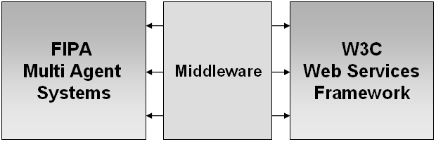

Figure 1: Middleware for required integration

2. Problems and challenges:
There is need of a middleware for required integration of Software Agents and Web Services. Devising solution to the problem was quite challenging. First reason to it is unstable specifications of Grid Computing which were known as OGSI and now have been re-factored as WSRF [1].
Secondly, both the technologies have different specifications as follows:
- Agents and Web Services use different communication protocol, i.e. Agents use Agent Communication Language (ACL) whereas Web Services use Simple Object Access Protocol (SOAP).
- Agents and Web Services use different service description languages, i.e. Agents use ontology named Directory Facilitator Agent Description (DF-Agent-Description) whereas Web Services use Web Services Description Languages (WSDL).
- Agents and Web Services use different service registries, i.e. Agents have Directory Facilitator (DF) based on FIPA specifications, whereas Web Services use Universal Description Discovery and Integration (UDDI) which is based on W3C specifications
We have performed a detailed comparative analysis [4] of both the technologies that includes service registries, service description languages and communication protocols which shows that both are quite different which caused required solution very challenging.

3. AgentWeb Gateway:
We proposed AgentWeb Gateway middleware [5] that provides solution for the above mentioned challenges by providing appropriate transformation mechanisms. The importance of this approach is that it enables integration of Software Agents and Web services without changing their existing specifications at the cost of time taken for translations which is negligible as compared to a transaction. We have done a detailed comparative analysis on service registries, service description languages and communication protocols of both the technologies and based on it we have proposed and implemented algorithm for required transformations.
We provide AgentWeb Gateway that acts as middleware between Multi Agent System and Web Services Framework and without changing existing specifications of both technologies. It provides Service Discovery transformation, Service Description transformation and Communication Protocol transformation. AgentWeb Gateway, without changing any specification of FIPA and W3C (agents and web services) can provide following features:

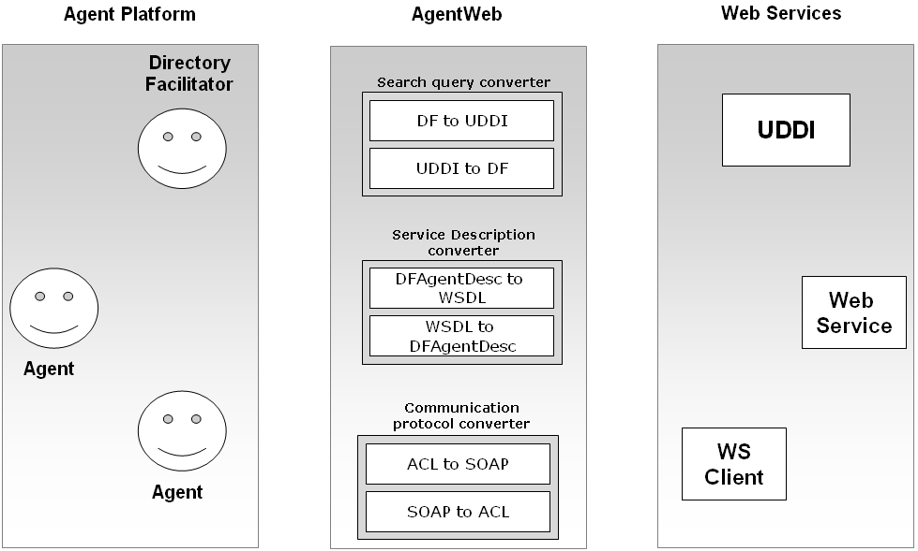

Figure 2: AgentWeb Gateway - system architecture

- Software Agents can discover Web Services in Web Service registry (UDDI)
- Software Agents can publish their services in Web Service registry (UDDI)
- Software Agents can invoke Web Services
- Web Service clients can discover Software Agents in Directory Facilitator (DF) of Agent Platform
- Web Services can be published in Directory Facilitator (DF) of Agent Platform
- Web Service clients can invoke Software Agents

4. Detailed design:
This section describes the detailed design of proposed system which consists of three major components.

4.1 Service Discovery converter
It enables service discovery among Software Agents and Web services i.e. Software Agents can do service discovery in Web Services registry as Universal Description Discovery and Integration (UDDI) and Web Service clients can do service discovery in Multi Agent Systems service registry as Directory Facilitator (DF). It can be divided into further two components which are:
4.1.1 UDDI search query to DF search query converter
It enables Web services clients to perform service discovery in DF of Agent platform.
4.1.2 DF search query to UDDI search query converter
It enables Software Agents to perform service discovery in UDDI of Web services platform.

4.2 Service Description converter
It enables service publishing among Software Agents and Web services i.e. Software Agents can publish services in Web Services registry as Universal Description Discovery and Integration (UDDI) and Web Services can be published in Multi Agent Systems service registry as Directory Facilitator (DF). It can be divided into further two components which are:
4.2.1 WSDL to DF-Agent-Description converter
It enables Web services to publish its services in DF of Agent Platform.
4.2.2 DF-Agent-Description to WSDL converter
It enables Software Agents to publish its services in UDDI of Web services platform.

4.3 Communication Protocol converter
It component enables service invocation among Software Agents and Web services i.e. Software Agents can invoke Web Services and Web Service clients can invoke Software Agents in Multi Agent Systems. It can be divided into further two components which are:
4.3.1 SOAP to ACL converter
It enables Web service clients to invoke Software Agents.
4.3.2 ACL to SOAP converter
It enables Software Agents to invoke Web services.

5. Testing and evaluation:
The proposed system has been tested on various real life scenarios and it was found successful in providing transformations among UDDI search query and DF search query to enable service discovery, WSDL and DF-Agent-Description to enable service publishing, SOAP and ACL to enable service invocation. AgentWeb Gateway has also provided successful support for required integration to our newly developed conference planner application [6] based on software agents, web services and grid services.

6. Conclusions:
In this draft, we have presented our solution for dynamic integration of Software Agents with Web Services without changing their existing specifications and implementation. The paper then describes design and implementation of a middleware, namely AgentWeb Gateway that facilitates required integration by providing two-way service discovery transformation, service description transformation and communication protocol conversion among FIPA compliant Software Agents and W3C compliant Web Service Framework.

References:

[1] Ian Foster, David Snelling, “Web Service Resource Framework – WSRF”, http://www.globus.org/wsrf/faq.asp, March 2004
[2] Ian Foster, Nicholas R. Jennings, Carl Kesselman, "Brain Meets Brawn: Why Grid and Agents Need Each Other", Proc. Autonomous Agents and Multi Agent Systems (AAMAS) July 2004.
[3] Foundation for Intelligent Physical Agents, FIPA Agent Management Specifications 2002, SC00023J, Geneva, Switzerland.
[4] M. Omair Shafiq, H. Farooq Ahmad, Hiroki Suguri and Arshad Ali, “Autonomous Semantic Grid: Principles of Autonomous Decentralized Systems for Grid Computing”, IEICE & IEEE Joint Journal, Special issue on Autonomous Decentralized Systems (ADS), to appear in December 2005.
[5] M. Omair Shafiq, Arshad Ali, H. Farooq Ahmad and Hiroki Suguri, "A middleware based approach for integration of Software Agents and Web Services", in 14th IEEE International Workshops on Enabling Technologies: Infrastructures for Collaborative Enterprises (WETICE-2005), June 13-15, 2005, Linkoping University, Sweden.
[6] M. Omair Shafiq, Arshad Ali, et al. “A Distributed Service Application using Software Agents, Grid Services and Web Services”,4th International Joint Conference on Autonomous Agents and Multi Agent Systems (AAMAS), 25 - 29 July 2005, Utrecht University, The Netherlands.

