IEEE FIPA P2PNA WG
Functional Architecture Specification Draft 0.12
Initial draft produced at Munich meeting, Jan 3 2006
Updated on February 3 2006

Objective (from WG Charter proposal)
Starting from existing FIPA specifications (in particular, FIPA JXTA Discovery Middleware Specification PC00095A and the experience acquired during its implementation), the objective is to define a specification for P2P Nomadic Agents, capable of running on small or embedded devices, and to support distributed implementation of applications for consumer devices, cellular communications and robots, etc. over a pure P2P network. This specification will leverage presence and search mechanisms of underlying P2P infrastructures such as JXTA, Chord, Bluetooth, etc. In addition, this working group will propose the minimal required modifications of existing FIPA specifications to extend their reach to P2P Nomadic Agents.

Functional Architecture
This architecture extends existing FIPA Agent Management specifications SC00023K and FIPA Agent Discovery Service Specification PC00095A towards general support of P2P, allowing leveraging of presence mechanisms, directories and search capabilities and linking to the existing FIPA search mechanisms in a seamless manner.

One particular aspect of this architecture it to allow new ways of coupling agents and peer systems. This coupling can be global between an agency and a peer system, or can be specific to each of the agents or each of the peers with a specific coupling policy to each of them. For instance these coupling policies can also control the life cycles of agents and peers and link them to perform operations together allowing making automatic update of agents by peers, or in other cases to manage peers by agents.

In the following of the document, the term peer represents a computational entity capable to share resource like – information, processing, presence, etc – with other peers, with at most a limited interaction with a centralized server.

The architecture has thee layers sitting on top of a communication network, as depicted in Figure 1:
- Generic Agent Services
- Agent platform (including platform services and Agent to peer interface)
- P2P (P2P Core and P2P Services)

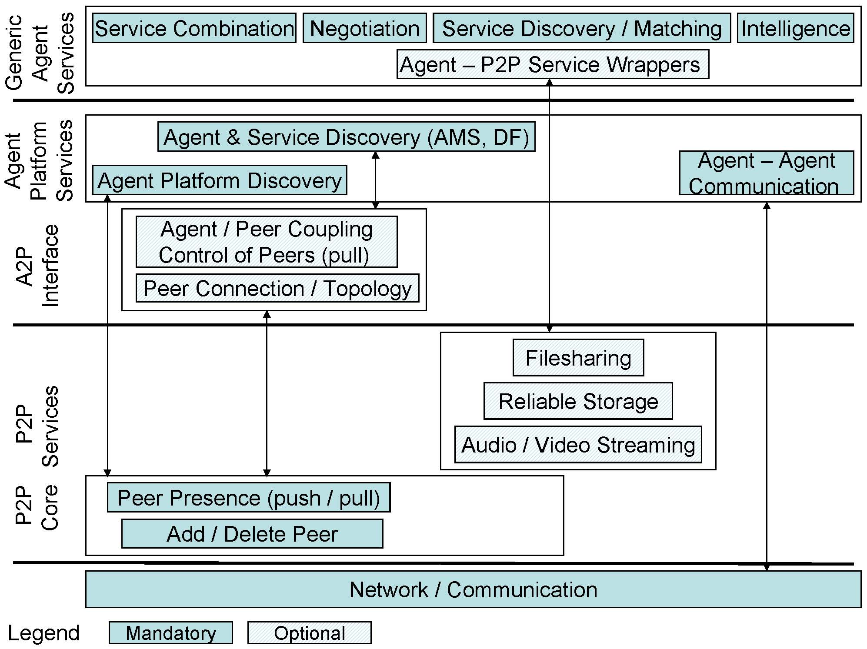
Figure 1: Functional Architecture of P2P Nomadic Agents

Generic Agent Services
These services are well known in the Agent Community, some of them have already been specified by FIPA and remain unchanged and they communicate via FIPA ACL. In particular the Agent – P2P service wrappers follow the specification of the FIPA wrappers (FIPA Agent Software Integration Specification XC00079) allowing agents to directly access P2P services (see arrow), such as - filesharing, reliable storage and audio/video streaming, … - . This direct access from agents to P2P services eases the development of agent applications by leveraging P2P services into the Agent framework.

Agent platform
Agent platform services are defined by FIPA and remain as much as possible unchanged:
- The Agent and service discovery mechanisms. The Agent Management System (AMS) is in charge of the agent life cycle and maintains an index of all the agents present on an agent platform. The Directory Facilitator (DF) is a service providing yellow pages for services provided by agents. Both AMS and DF have been defined in the FIPA Agent Management specifications SC00023K, and might be linked to the Agent/Peer coupling service allowing to link AMS and DF updates to presence/absence of peers through policies. This provides a versatile coupling mechanism capable to keep the coherency of a system including agents and peers. This coupling service is described in details in Annex 1.
- The Agent Platform discovery mechanism is the FIPA Service finding platforms and connecting to them. This service has been extended to connect also to peer architectures, as specified in FIPA Agent Discovery Service Specification PC00095A for which a specific instance has been provided in the FIPA JXTA Discovery Middleware Specification document PC00096.
- The Agent-Agent communication mechanism is the mechanism specified in the FIPA ACL, and it can directly connect to the communication mechanisms and network (see arrow).

A2P interface (New)

- The Agent/Peer coupling system links an agent system to a P2P system (and vice-versa) at very fine granularity through policies down to the agent and peer level, allowing them to interoperate by connecting their life cycles through policies. These policies can be changed, independently for the application. These policies allow expressing agent to peer couplings like: agent driven mode where agents control the life cycle of peers; peer-driven mode where peers control the life cycle of agents; independent mode where agents and peers communicate but do not control each other; specific modes where each agent and each peer can be linked by their own policy; and finally policies allowing error recoveries between agent and peer systems. See next section for detailed specification.
- The peer connection/topology is a service indicating all the direct connections of a given peer (single hop) and optionally the nature of this connection (TCP/IP, Bluetooth…). The result of this service is a list of the related peer’s IDs and optionally the nature of their link. This service allows building the topology of the network which is important in the deployment and exploitation of heterogeneous P2P networks.
P2P
P2P Services
These services are examples of well known functions in the P2P community. They can be wrapped by FIPA agents and used directly as agent services. Examples of such services are: file sharing, reliable storage, audio/video streaming, etc.
This architecture allows plugging additional services according to the application field providing agents a convenient development environment encompassing access to P2P services whenever needed.

P2P Core
The Peer presence mechanism is a service indicating if a peer is currently connected or not, through a simple presence bit. It can be accessed in two manners:
- Query mechanism (pull)
- Subscribe mechanism (push) pushing presence changes towards subscribers.

In addition the peer presence mechanism supports also the life cycle management of peers and in particular provides an API for the creation and the deletion of peers, so that agents could potentially manage the life cycle of peers (policies permitting).

Agent/Peer Coupling System

The Agent/Peer coupling system allows linking agent life cycles, as defined in the FIPA Agent Management specifications SC00023K, to peer life cycles which are basically defined by the connected and disconnected states as provided by the peer presence mechanism.

This coupling system works with policies, allowing modifying the couplings of agent and peer systems, independently of the application layers, providing the following advantages:
- Agent/Peer coupling problems are treated at this layer, so as to free applications from error handling,
- Peer presence can automatically update agent systems providing an automatic connection hence more robust, adaptive and scalable applications,
- Agents can bring reasoning capabilities to large scale applications when and where needed.

Figure 2: Functional Specification of a P2PNA System

The agent/peer coupling module contains a peer and an agent triggered updating mechanisms working concurrently and the following data structures:
- Agent2Peer conversion table A2PCT linking agents to their related peers, see Table 2,
- Peer2Agent conversion table P2ACT linking peers to their related agents, see Table 3,
- Policies Table, providing both the request and the update policies, see Table 4.

Peer triggered operations
The peer presence mechanism monitors the peer presence (connect <peer>, disconnect <peer>). If a change is detected, a query is sent to the P2ACT to update related agents (r_agents), apply their policies to define the actions on the agent network (create <r_agent>, quit <r_agent>). These actions are sent to the AMS answering with (success <message>, failure <message>) to the A2PCT table. The latter updates the presence of the agents and sends the evaluation of the update policy to the related peers. This closes the loop with the P2P system and its presence service. See details in Figure 3.
Figure 3: Peer driven operations

Example: Ad hoc sensory networks are built bottom up, each of the sensors collects information, performs basic recognition or signal processing, detects a communication path to other sensors and transmits data. The information collected by these peer sensors, needs to be consolidated to remove noise, incorporate additional data like topology of the sensory network and interpret data to fulfill a service like a pattern recognition. In the proposed infrastructure peer sensors can trigger interpretation agents according to the type of signals they detected hence building the network control in a contextual and opportunistic manner. For instance, a network of chemical and bacteriological peer sensors monitors air quality and launches specialized agents to analyze precisely the nature of the pollution determine its cause and establish countermeasures. Policies for such networks can be expressed in the following, where a detection of carbon monoxide (CO) would launch CO Alarm agents in charge of public safety procedures and the detection of the source of the CO.

Table 1: Peer sensors detect signals and launch appropriate interpretation agents
 | Agent | Peer
Request |  | connect <Peer_CO_Detection>  ->create <Agent_CO_Alarm>  disconnect<Peer CO_Detection>  -> quit <Agent_CO_Alarmt>
Update | success (create <Agent_CO_Alarm>)  -> Peer_CO_Detection  success (quit <Agent_CO_Alarm>)  -> Peer_CO_Detection  failure (create <Agent_CO_Alarm>)  -> Peer_CO_Detection  failure (quit <Agent_CO_Alarm>)  -> Peer_CO_Detection

This elementary example, shows how to link peers to agents in a modular manner, peers drive the system, create and kill agents as required (peer request cell). The update policy (Agent Update cell) reports the status of the agent creation or termination to the peer system.

Agent triggered Operations
Changes in the Agent life cycle management operations: create <agent>, destroy <agent>, quit <agent> are detected by the AMS and trigger a query to the A2PCT, define the related peers (r_peers), apply their policies to define the actions on the P2P network (connect <r_peer>, disconnect <r_peer>). These actions are sent to the P2P network which updates the Presence service, and sends (success <message>, failure <message>) to the P2ACT table. The latter updates the presence of the peers and sends the evaluation of the update policy to the related agents. This closes the loop with the agent system and its AMS. See details in Figure 4.
Figure 4: Agent Driven Operations

Example: In future home Audio Video (AV) systems, all devices DVD, DVR, Plasma TV, HiFi, Camera, phones, MP3 players …will be connected through a wireless network providing high level services like IP video conference, AV theater, healthcare etc. To make this vision a reality, there is a need to link these high level services represented by agents performing configuration management, to devices represented by peers providing resources like video capture, display. While the peer devices connect and disconnect from the home network due to mobility and user interaction, the configuration agents are always searching for new resources capable to provide services to users.

The Agent2Peer Conversion Table
The Agent2Peer Conversion table is an extension of the FIPA AMS allowing:
- Linking agents to their related list of peers through some policies
- Reporting the presence of agents and making it available to peers
Additional fields to the ones standardized by FIPA are represented in Bold.

Table 2: Agent2peer Conversion Table (A2PCT) (Fiedls new to the AMS are in Bold)
parameter | Description | Presence | Type
Agent | The identifier of the agent | Mandatory | Agent identifier
Agent-presence | Boolean presence of agent | Optional | Bool
Agent Update Policy | Agent Update Policy | Optional | Set of string
List of related Peers (r_peers) | List of peer definition | Optional | Peer definition:  - peer identifier,  - agent request policy
services | List of services supported by the agent | optional | Set of service-description
protocols | List of interaction protocols supported by the agent | optional | Set of string
ontologies | List of ontologies known by the agent | optional | Set of string
languages | List of content languages known by the agent | optional | Set of string
Lease-time | Duration or time at which the lease of the agent registration will expire | optional | Datetime
Scope | Visibility of agent, local or global | optional | Set of string

The Peer2Agent Conversion Table
The Peer2Agent Conversion table is an extension of the peer presence mechanism, extending it towards the following directions:
- Linking peers to their related list of agents through some policies,
- Reporting the presence of existing peers in the peer system and make this information available to the agents in the agent system.

Table 3: Peer2agent Conversion Table (P2ACT)
parameter | Description | Presence | Type
Peer-name | The identifier of the peer | Optional | Peer identifier
Peer-presence | Boolean presence of peer | Optional | Bool
Peer Update Policy | Peer Update Policy | Optional | Set of String
List of related Agents (r_agents) | List of agent definition | Optional | Agent definition:  - agent identifier,  - peer request policy

The Policy Table
The policy table contains policies linking agents and peer life cycles. As the policies are mainly concerned with the creation and deletion of agents and peers, they deal with the three states of the agent life cycle supported by the AMS (create, destroy, quit) and the two stated of the peer life cycle (connect, disconnect).Policies can be subdivided in four categories:
- peer-request policies, applied when peers request an operation on agents
- peer-update policies, applied when peers update an operation on agents
- agent-request policies, applied when agents request an operation on peers
- agent-update policies, applied when agents update an operation on peers

In each of these categories there might be several policies, each of which is identified by a unique name.
Table 4: Policy Table (PT)
parameter | Description | Presence | Type
Peer-Request Policy definition | List of policies for the peer ‘connect’, ‘disconnect’ operations | Optional | Set of string
Peer-Update Policy definition | List of policies for the peer ‘connect’, ‘disconnect’ operations | Optional | Set of string
Agent-Request  Policy definition | List of policies for the agent ‘create’, ‘destroy’, ‘quit’ operations. | Optional | Set of string
Agent-Update  Policy definition | List of policies for the agent ‘create’, ‘destroy’, ‘quit’ operations. | Optional | Set of string

